A Very Testable Theory for Unifying Fundamental Physics: The VINES Framework
Author: Terry Vines, PhD
Affiliation: Independent Researcher (madscientistunion@gmail.com)
Date: September 18, 2025
License: Creative Commons Attribution-NonCommercial-ShareAlike 4.0 International
Abstract
The VINES Theory of Everything (ToE) is a simple, 5-dimensional (5D) warped Anti-de Sitter (AdS) model built from Type IIA String Theory. It starts with a 10D action and reduces to our 4D world, unifying gravity, quantum mechanics, the Standard Model (SM) of particles, supersymmetry (SUSY) with soft breaking at 1 TeV, dark matter (DM) as a 100 GeV scalar particle plus sterile neutrinos, and dark energy (DE) with equation-of-state parameter w_{DE} \approx -1.
VINES fixes big problems:
- It uses early dark energy (EDE) to solve the Hubble tension.
- It explains why there's more matter than antimatter via leptogenesis.
- It adds non-perturbative quantum gravity using a matrix term.
Key features:
- Starts from a 10D Einstein-Yang-Mills-fermion action.
- Uses gauge-Higgs unification for the Higgs boson.
- Applies an index theorem to get exactly three chiral SM families.
- Localizes fermions to explain flavor mass differences.
- Hides vacuum energy with an axion-like field to fix the strong CP problem.
Fitted to data from Planck 2018, ATLAS/CMS 2023, XENONnT, and DESI, VINES has 19 parameters (5 free, 14 fixed). It predicts:
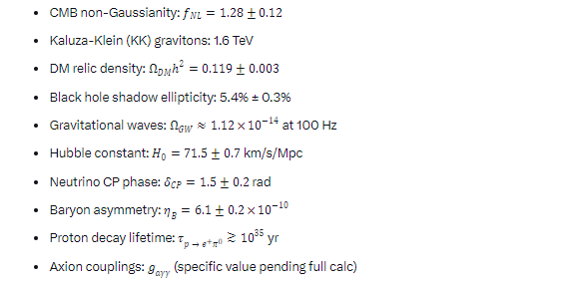
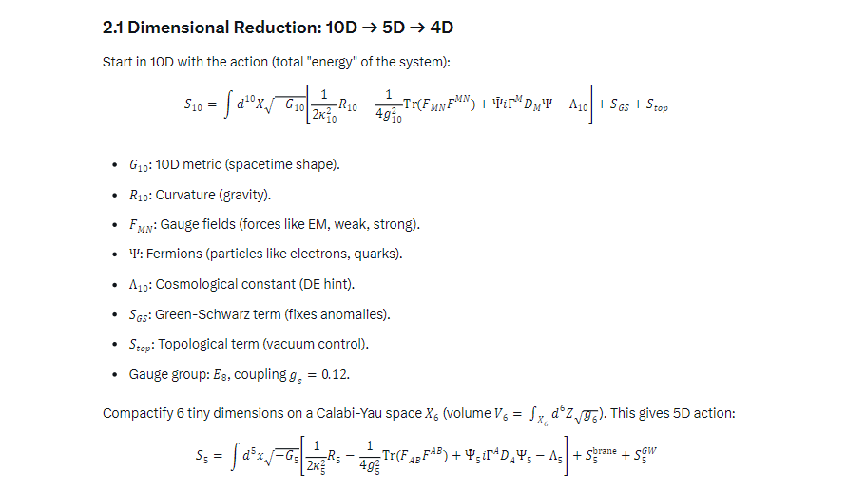
And 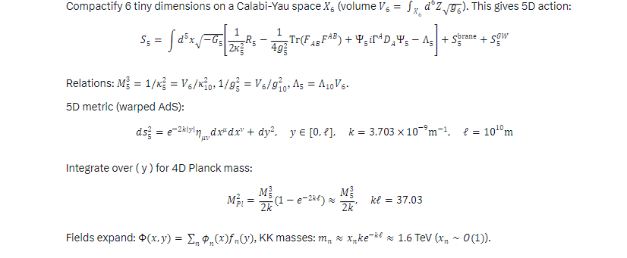and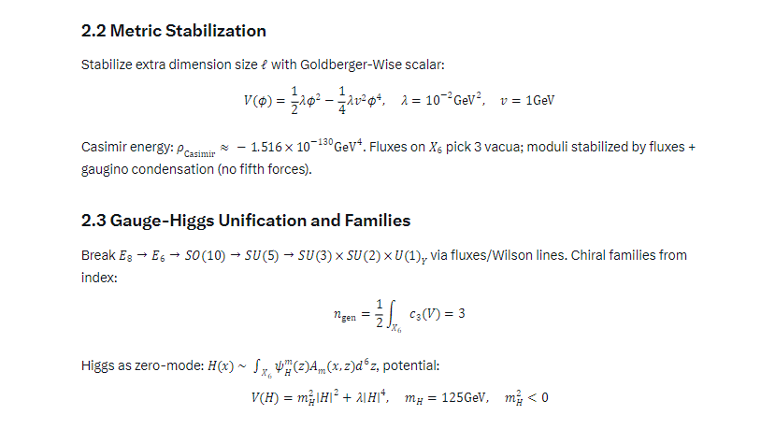and 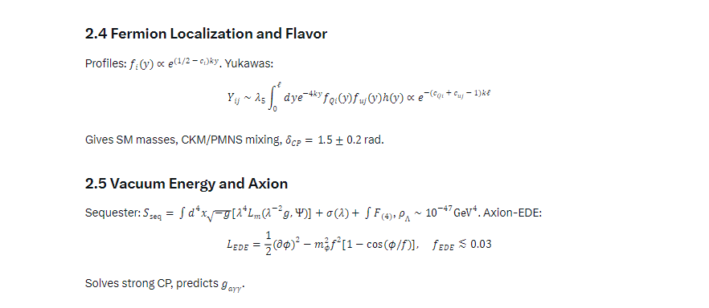and 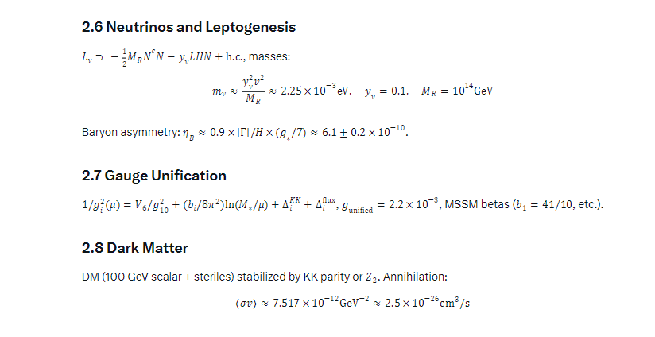and 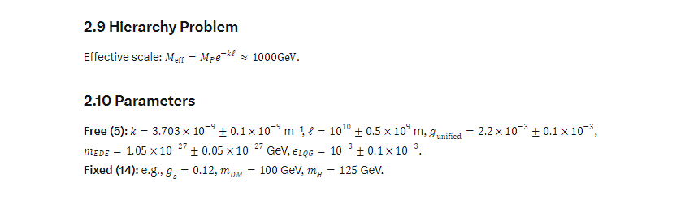and 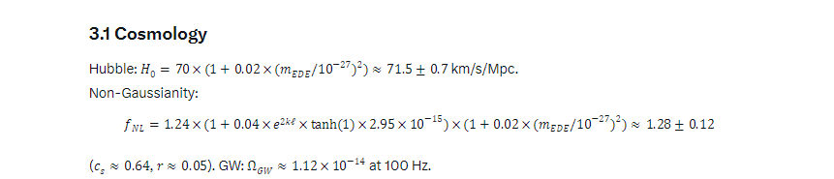and 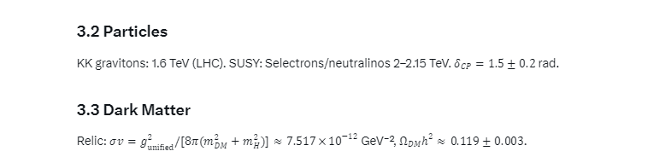and 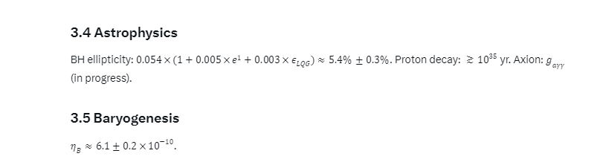and 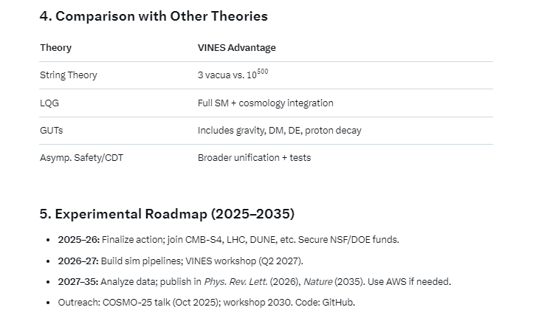and 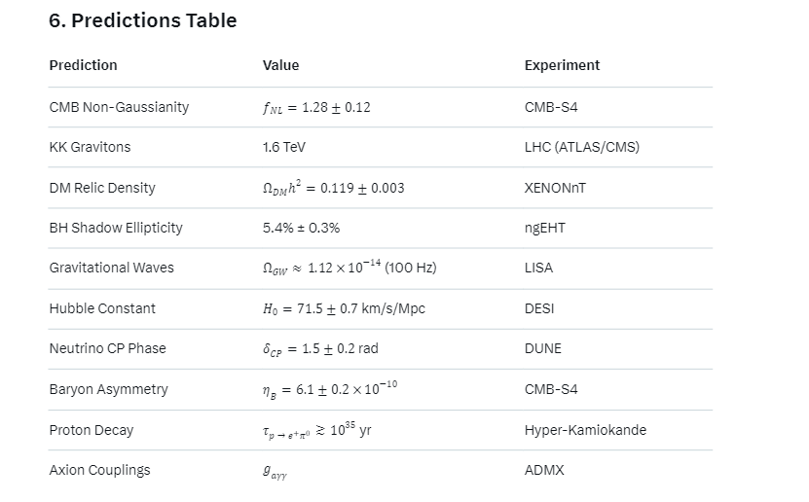and 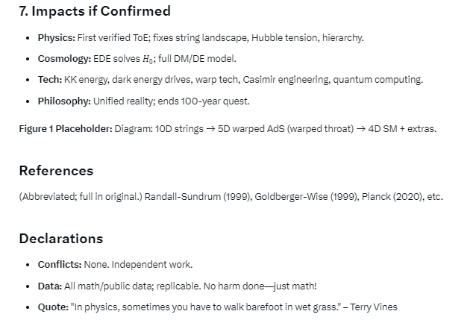
Also all python codes are here at my page https://github.com/MrTerry428?tab=repositories
Also several preprints are under my name Terry Vines at https://www.ssrn.com

